**COVID REPORTING SYSTEM**



**Project Team Members**

**1.Garikipati Lahari. (TEAM LEADER)**

**2.Gopaldas Venkata Naga Sai Thoshini.**

**3.Kandula Lakshmi Prasanna.**

**4.Dhulipala Jaya Chandra Sekhar.**

**1.0 DOCUMENT PURPOSE**

Covid-19 has put the world to a standstill. Doctors, healthcare workers and personnel of many other essential services are fighting at the frontline to tackle this global pandemic. Although we are not fighting the battle at the frontline, as a citizen this is our humble attempt at partaking in the struggle.

In this we discuss about people who get registers in our website they like to know about their health condition and status of vaccination.

This project aims to develop content in the **COVID-19** modules such as

1. Registration for Testing

2.Covid Effected

3.Recovered

4.Registration for vaccination.

5.Vaccinated Members.

6.Death Members.

**2.0 Modules Use Cases**

**2.1 Registration for Testing**

In this module, user have to register to access the website and user can register for Covid testing. Testing strategies should be flexible and rapidly adaptable to change.

Ideally, all people with COVID-19 symptoms should be tested as soon as possible after symptom onset. This requires easy access to testing for all, including non-residents. Test turnaround time should be minimized.

He/she will go to register page by providing the required details like,

* Full Name
* Age
* Gender
* Mobile Number
* Adhar Number
* Address

**2.2 Covid Effected**

In this module, we find the list of persons who has effected with covid and displays the details of effected person’s. The most common symptoms of this viral infection are fever, cold, cough, bone pain and breathing problems, and ultimately leading to pneumonia. This, being a new viral disease affecting humans for the first time. The following are the parameters that displays in this module.

* Full Name
* Adhar Number
* Mobile Number
* Effected Date

**2.3 Recovered**

Recovered simply refers to people diagnosed with COVID-19, hospitalized, and then discharged from the hospital recovery on a certain number of days—generally between 14 to 30. In this module, it displays the recovered person’s details like,

* Full Name
* Adhar Number
* Mobile Number
* Recovered Date

**2.4 Registration for vaccination**

In this module, user have to register for Covid vaccination. Certificate of vaccination will be provided by government on completion of the second dose of the Covid-19 vaccine.

Two Covid-19 vaccines that have been granted emergency use authorization by the Central Drugs Standard Control Organization (CDSCO). In India, available vaccines are Covishield and Covaxin (manufactured by Bharat Biotech Limited). He/she will go to vaccination page by providing the required details like,

* Full Name
* Age
* Gender
* Mobile Number
* Adhar Number
* Address

**2.5 Vaccinated Members**

In this module, we can find the details of vaccinated members who has previously registered for taking vaccination. We defined receiving two COVID-19 vaccinations as the weighted percentage of respondents who reported receiving “2 vaccinations or doses”. It contains the fields like,

* Full Name
* Age
* Gender
* Date of Vaccination
* Mobile Number
* Adhar Number
* Address

**2.6 Death Members**

In this module, we can find the list of persons who died due to COVID. The death causes due to lack of treatment and oxygen facilities. The top global causes of death, in order of total number of lives lost, are associated with three broad topics: cardiovascular, respiratory conditions. It contains the fields like,

* Full Name
* Age
* Gender
* Date of Death
* Mobile Number
* Adhar Number
* Address

**3.0 Design and Implementation Constraints**

**3.1 Database**

The system shall use the MS SQL Server Database, which is open source and free.

**3.2 Operating System**

The Development environment shall be Windows10.

**3.3 Web-Based**

The system shall be a Web-based application ASP.Net.

**4.0 Define module & Functionality**

The system functions can be described as follows:

**4.1 Registration**

When the user enters the page, they have to register to visit the website. They can access the different modules in the website.

**4.2 Register for Vaccination**

When the user enters the page, they have to register for vaccination, who want to take vaccine. They can access the different modules and they can know status of vaccination.

**5.0 System Analysis**

System analysis is the first and foremost step performed in developing the software to solve a particular problem. In the analysis part, a software developer examines the requirements. Carrying out preliminary investigation identifies these requirements

Analysis consists of two sub phases:

1. Planning
2. Requirement definition

During planning phase, cost estimates and work schedules will be planned. Requirement definition is a specification that describes the processing environment, the required software functions, performance constraints (Size, Speed, Machine Configuration) and exception handling.

**6.0 Use Case Diagram**

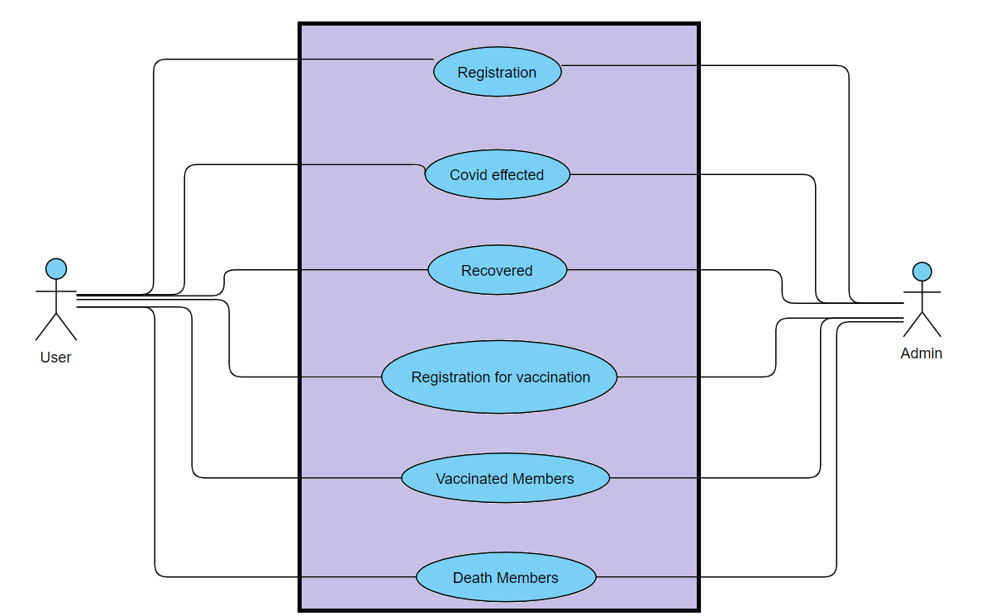

**8.0 Class Diagram**

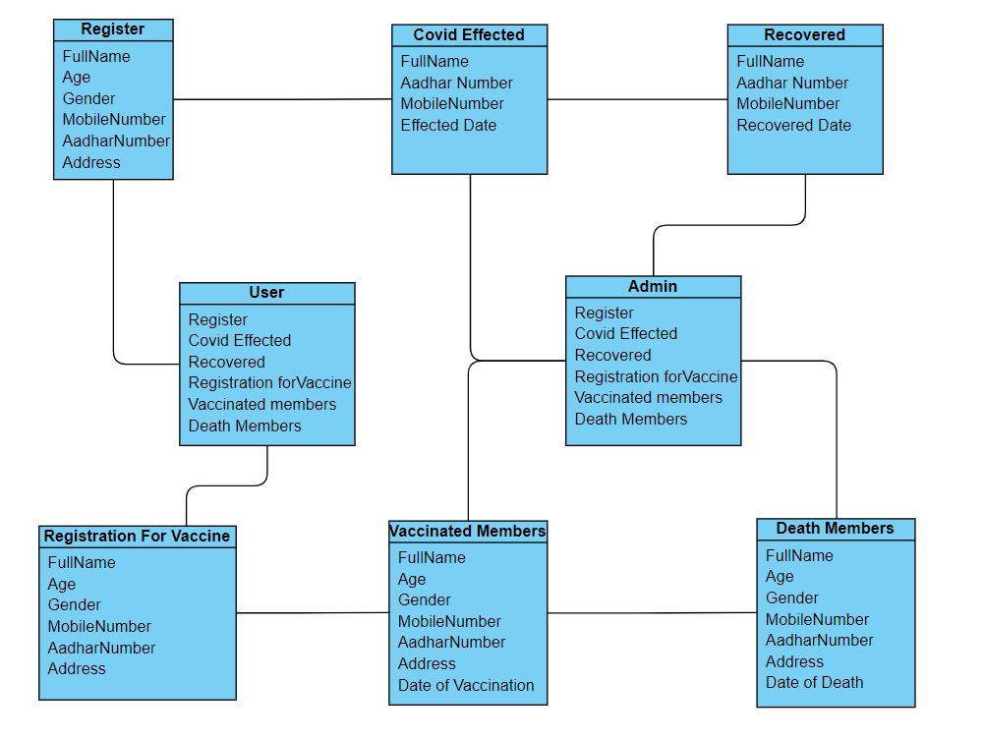

**9.0 Sequence Diagram**

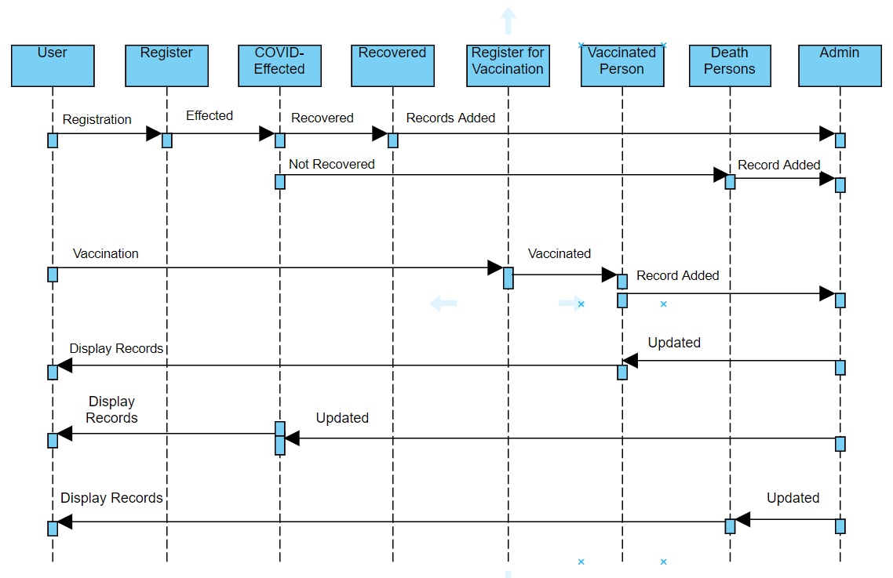

**10.0 Technical**

* HTML
* CSS
* JQUERY
* SQL
* MVC
* Validation
* BOOTSTRAP v4

**11.0 Conclusion**

COVID REPORT SYSTEM (CRS) provides the information about the person who has register for Covid test, who has effected with **Corona Virus,** it also gives details of recovered person, it gives details of person who had register for vaccination and retrieve the details of vaccinated person and also death person’s data.

Our Website is used for the quick data access and retrieving the information of person in this COVID situation. And it is generally used in Hospitals, Government survey, own users.